# Networking Lab 3 Routers

## IP Addresses

The biggest question a computer must answer about an IP address is: “Is the address I want to talk to on my network (use ARP and talk directly) or is it on another network (use default gateway)?”

Together, the IP address and subnet mask let you answer that question. In binary, the subnet mask will be all ‘1’s in the network portion, and ‘0’s in the host portion. The easiest mask is 255.255.255.0

255.255.255.0  
11111111.11111111.11111111.00000000

For the IP address 192.168.15.162, that breaks down to this:

|  |  |  |  |
| --- | --- | --- | --- |
| 192. | 168. | 15. | 162 |
| 11111111. | 11111111. | 11111111. | 00000000 |

The network portion of 192.168.15.162 is 192.168.15.0. Any address that starts with 192.168.15 is on the same network, and anything else is on a different network. Note that there are 256 (0 - 255) possibilities for the host portion of the address; in the example above the host portion is 162. There are two reserved numbers, however. The lowest possible host number (0 in this case) is reserved for the network itself, so the network above is 192.168.15.0. The highest possible host number (255 in this case) is reserved for the network broadcast address, so 192.168.15.255 would be sent to all hosts on the 192.168.15.0 network.

For this lab, we will use a 255.255.255.0 subnet mask, and network addresses starting with 192.168.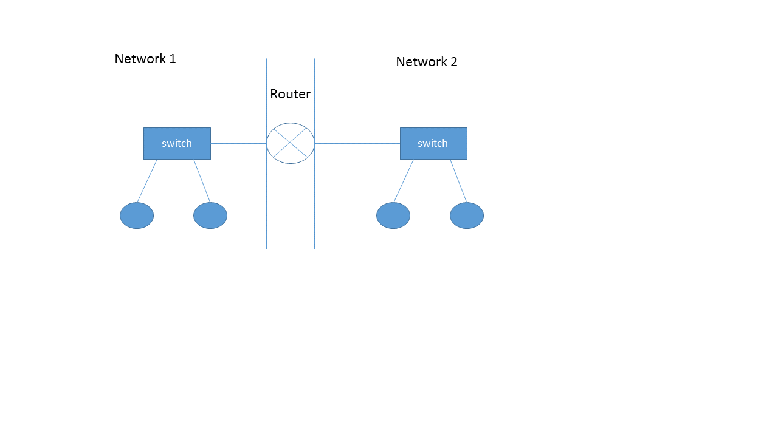

Subnet address:__________________________ Subnet address:__________________________

Subnet mask:____________________________ Subnet mask:____________________________

Default Gateway:_________________________ Default Gateway:_________________________

Host 1:_________________________________ Host 3:_________________________________

Host 2:_________________________________ Host 4:_________________________________

1. Configure your lab as shown above. The instructor will give you a subnet address and mask. Select a default gateway address for each side. The two sides should be on different subnets. Select addresses for the hosts that are on the correct subnet for their sides.
2. The instructor will configure the router with the gateway addresses you’ve selected.
3. Test to see that you can ping the other host on your subnet and a host on the other side of the router. Troubleshoot as needed.
4. Record the MAC addresses for your hosts, and for the default gateways (the two router interfaces.) If you ping the router, you should be able to find its MAC address by examining the arp cache on your host (Linux: the command is arp; Windows: the command is arp –a)
5. Same Subnet. Start a Wireshark packet capture. We will send a netcat or ncat message (or just a ping) to the other host that is connected to your switch. It should be on the same subnet as your host. First, though, start a Wireshark packet capture on both hosts.
   1. What MAC addresses appear in the packets (ie, what hosts do they belong to?)
   2. Look at the entries in your arp cache. Is the entry of the other host in the cache?
   3. Compare the source and destination MAC addresses in the Wireshark captures from each host. How are they related?
   4. Compare the source and destination IP addresses in the Wireshark captures from each host. How are they related?
6. Different Subnets Repeat step 4, except send the message or ping to a host on the other side of the router. How do your answers compare to what you had in step 4?
7. Hand In Start a packet capture on your host at the same time a student on the other side of the router starts a capture on theirs. Next, one of the hosts should ping the other and then both stop the captures. Find the pings in both packet captures and compare them. How can you use the two captures to prove that the router rewrote the Layer 2 portion of the packets?